PROJECT REPORT

*On*

# “Heart Failure Risk Prediction System”

*Submitted in the fulfilment of the requirement for the award of the degree of*

## BACHELOR OF COMPUTER APPLICATION

*by*

## Anamika Mani Tripathi (2514058590014), Anshu Kushwaha (2514058590017),

**Nainsee Yadav (2514058590030), Jyoti Gupta (2514058590037)**

*Under The Supervision of*

## Mr. Prashant Sharma

(Asst. Prof.CA)



**Department of Computer Application**

**Buddha Degree College GIDA, Gorakhpur 273209 (U.P.) India**

**Affiliated To**

**Deen Dayal Upadhyaya University Gorakhpur-273009 (UP), India**

**April 2025**

**© Buddha Degree College GIDA, Gorakhpur, (U.P.) – 273209, INDIA ALL RIGHTS RESERVED**

# DECLARATION

We, the undersigned students of **Buddha Degree College, Department of Computer Application**, declare that the report titled **“Heart Failure Risk Prediction System”** is a collective effort undertaken by the following group members:

* **Anamika Mani Tripathi** (2514058590014)
* **Anshu Kushwaha** (2514058590017)
* **Nainsee Yadav** (2514058590030)
* **Jyoti Gupta** (2514058590037)

This report is submitted in the partial fulfillment of the requirement for the award for Degree of Bachelor of Computer Application. The work presented is this report was conducted under the guidance of **Mr. Prashant Sharma** (Asst. Prof.CA).

We further declared that the content of this report has not been previously submitted for a degree or any other qualification at this university or any other institution. We have also ensured that all sources used in the preparation of this report have been properly acknowledged and cited.

# CERTIFICATE

This is to certify that the project titled **“Heart Failure Risk Prediction System”** is an Academic work done by **“Anamika Mani Tripathi, Anshu Kushwaha, Nainsee Yadav, Jyoti Gupta”** submitted in the partial fulfillment of the requirement for the award of the Degree for **“Bachelor of Computer Application”** from **“Buddha Degree College GIDA, Gorakhpur”** under my supervision and direction. To the best of my knowledge and belief the data and the information presented by them in the project has

submitted earlier.

(Signature of Supervisor)

**Mr. Prashant Sharma**

(Assistant Professor)

Computer Application Department

BDC GIDA, Gorakhpur

# APPROVAL SHEET

This report entitled **“Heart Failure Risk Prediction System”** by **“Anamika Mani Tripathi, Anshu Kushwaha, Nainsee Yadav, Jyoti Gupta”** is approved for the degree of Bachelor of Computer Application.

**External Examiners**

## Mr. Prashant Sharma

(Supervisor & Assistant Professor)

CA Department

**Internal Examiners**

## Mr. Prashant Sharma

(Professor and HOD)

CA Department

# ACKNOWLEDGEMENT

We are grateful to our esteemed guide, Mr. **Prashant Sharma,** for his invaluable guidance and support throughout this project. Her insightful feedback, encouragement, and willingness to dedicate their time significant contributed to the successful completion of this report.

We would also like to express our sincere appreciation to the faculty and staff of the CA department. Their dedication to create a simulating learning environment and their willingness to supply resources and answer our questions were instrumental in allowing us to delve deeper into the subject matter.

A special thanks goes to Respected our **HOD Mr. Prashant Sharma** for his support.

Finally, we extend our heartful thanks to our friends for their unwavering support and encouragement throughout this project.

**ABSTRACT**

Heart failure is a critical cardiovascular condition that affects millions worldwide, often leading to severe health complications and mortality if not detected early. This study presents a **“Heart Failure Risk Prediction System”** that leverages machine learning techniques to assess an individual's risk of developing heart failure based on key clinical parameters. The system utilizes patient data, including demographics, medical history, and lifestyle factors, to generate predictive insights that aid in early diagnosis and preventive healthcare.

The proposed system incorporates advanced algorithms such as logistic regression, decision trees, and neural networks to enhance predictive accuracy. By integrating real-time data processing and an intuitive user interface, the system provides healthcare professionals with a reliable tool for early intervention and personalized patient care. The results demonstrate the model’s effectiveness in identifying high-risk individuals, potentially reducing hospitalizations and improving patient outcomes.

This research highlights the importance of AI-driven healthcare solutions in mitigating cardiovascular diseases and underscores the potential of predictive analytics in transforming medical diagnostics and patient management.

**TABLE OF CONTENT**

**Declaration i**

**Certificate ii**

**Acknowledgement**  **iii**

**Abstract** **iv**

**List of Figures v**

**Chapter1.Introduction** .......................................................................................................... **1-13**

* 1. 1.1Objective 01
  2. 1.2Literature Review 03
  3. 1.3Problem Definition .................................................................................................. 09

1.4Existing System 09

* 1. 1.5Proposed system 09
  2. 1.6Propose Model 10

1.7Project Goal .......................................................................................................... 11

1.8Hardware Requirement .......................................................................................... 12

* 1. 1.9Software Requirement …………………………………………………………… 13

**Chapter 2. System Analysis&Design** **14-38**

* 1. 2.1Project scope 14
  2. 2.2Flow chart 16
  3. 2.3Model Pipeline 17
  4. 2.4Timeline 18
  5. 2.5System Architecture 30
  6. 2.6Machine learning model 35

2.7Proposed Algorithm 38

**Chapter 3. ImplementationandResults** **36-54**

3.1Implementation .................................................................................................... 36

3.2Deploy model using flask 39

3.3Implementation Code 39

3.4Result Analysis 54

**Chapter 4. Conclusion and Future Enhancements** **55-56**

4.1Summary of work done 55

4.2Conclusion 55

4.3Scope of future enhancement 56

**References**

**Appendices**

**Project**

**Code**

* Progress Report by Guide
* Research Paper Published/Communicated
* Plagiarism Report

# Chapter 1 Introduction

**Abstract with Objectives: -**

**Abstract: -**

The objective of assessing heart failure (HF) risk is to identify individuals at risk of developing the condition, implement preventive measures, and optimize treatment strategies to improve patient outcomes by recognizing risk factors such as hypertension, diabetes, coronary artery disease, obesity, and lifestyle habits, healthcare providers can intervene early to prevent disease progression. Various traditional methods, based on physical and chemical tests, are available for diagnosing heart. Data science methods have the potential to benefit other scientific fields by shedding new light on common questions. Machine learning is an emerging scientific field in data science dealing with the ways in which machines learn from experience. This research focuses on recent developments in machine learning which have made significant impacts in the detection and diagnosis of heart. This also aims to enlighten the analysis of the attributes which are majorly affected.

**Objectives: -**

Machine learning is the scientific field with main characteristic of an entity called intelligent in the broadest sense of the world. Through machine learning, computer systems can be developed which can learn and adapt from past experiences. Through proper assessment of signs of symptoms early detection and diagnosis of heart is possible. Several classification techniques are used by scientists for developing the model of prediction of risk of the disease. We require a dataset, containing the information or data of diabetic patient or diabetic prone patient. This dataset contains data of 1319 patients. This dataset is in the form of questionnaire gathered through Zheen hospital. (Heart Hospital which is in Erbil) Iraq. Analysis of data has been done through several algorithms such as Random Forest, Naive Bayes, Logistic Regression. Tenfold Cross- Validation and Percentage Split evaluation has also been applied.

The objective of the research is to find out new features and factors that can bring a literal change in the prediction of heart failure risk, Verifying the accuracy and classification of Logistic Regression.

Find the correlation, to identify which attributes has the major impact which result into heart

failure risk.

* 1. **Literature Review: -** In past the classification on diverse types of datasets that can be accomplished to decide if a person is heart attack or not. The Herat Attack patient’s dataset is established by gathering data from hospital warehouse which contains one thousand three hundred nineteen instances with nine attributes. In this study the implementation can be done by
  2. using WEKA to classify the data and the data is assessed by means of 10-fold cross validation approach, as it performs very well on small datasets and instances are less relevant and the outcomes are compared. The Naïve bayes, j48, REP tree and Random Tree are used. It was concluded that J48 works best showing an accuracy of 60.2% among others.

Before it aims to discover solutions to detect the heart attack by investigating and examining the patterns originate in the data via classification analysis by using Naïve Bayes, Random Forest and Logistic regression algorithm. The research hopes to propose a faster and more efficient method of identifying the diseases that will help in well-timed cure of the patients. Heart attack dataset and cross validation instances for each type of class labels. Therefore, we consider resample as one approach to enhance classification accuracy.

**Problem definition: -**

Diseases that have already affected 422 million people worldwide according to the report of World Health Organization (WHO), in 2023. Due to the presence of a relatively long asymptomatic phase, early detection of heart failure risk is always desired for a clinically meaningful outcome. Around 50% of all people suffering from Heart Attack are undiagnosed because of its long-term asymptomatic phase. The early diagnosis of heart attack is only possible by proper assessment of both common and less common sign symptoms, which could be found in different phases from disease initiation up to diagnosis. Data mining classification techniques have been well accepted by researchers for risk prediction model of the disease. To predict the likelihood of having heart requires a dataset, which contains the data of newly Heart Failure or would be Heart Attack patient. We have analyzed the dataset with Naive Bayes Algorithm, Logistic Regression Algorithm, and Random Forest Algorithm and after applying tenfold Cross- Validation and Percentage Split evaluation techniques, Finally, a commonly accessible, user-friendly tool for the end user to check the risk of having heart attack from assessing the symptoms and useful tips to control over the risk factors has been proposed.

In this study, total 1319 participants are selected aged 18 and above. The participants were asked to answer a questionnaire which was self-prepared based on the constraints that could lead to heart attack:

Age 1.20-85

Gender 1. Male, 2. Female

Heart Rate 60-140

Systolic Blood Pressure 90-200

Diastolic Blood Pressure 60-80

Blood Sugar 80-350

CK-MB 0-4

Troponin 0-10

Result 0-Negative, 1-Positive

**Existing System: -**In India, Heart Attack is a widespread problem as more than 70% of the adult population is suffering from this disease. Various researchers have worked to predict symptoms of heart attack by applying different approaches such as machine learning and data minimum. Few of them have also applied neural network and genetic algorithm. Since the problem of prediction of heart attack is supervised in nature, the supervised methods of machine learning, data mining and ANN have been applied by many. Some closely related works are discussed in this section. Many of the research studies have used Pima Indians Heart Dataset (PIHD) for heart failure prediction system. Machine learning methods and Weka tool were applied by [13, 14, 16, 17, 20, 21, 23]. The different approaches applied by researchers can be broadly classified as machine learning methods, data mining techniques, hybrid methods and neural network or genetic algorithms. Swapna et. al. in [12] used deep learning methods on electrocardiogram (ECG) signals for detection of heart. Specifically, convolution neural network and long short-term memory has been used by them and then features were extracted by Logistic Regression. As a result, they found a very high accuracy of 81%. Sisodia et. al. in [13] applied three machine learning methods i.e. Decision Tree (DT), Naïve Bayes (NB) and Support Vector Machine (SVM) on PIDD to predict the Heart Attack Naïve Bayes classifier was found to be 76.30% accurate.

**Proposed system: -**

In view of the problem statement described in the introduction section, we propose a classification model with boosted accuracy to predict the Heart Attack patient. Classification is one of the most important decision-making techniques in many real-world problems. In this work, the main objective is to classify the data as Heart Attack and improve the classification accuracy.

Jupyter Notebook was used for implementation and Python programming language was used for coding. Machine learning algorithms **like logistic regression**, k-nearest neighbor, support vector machine, naive bayes classifier, decision tree and random forest classifications were implemented on the dataset collected to predict Heart. All these predictions from each classifier are then compared with each other.

**Proposed Model: -**

The following are the steps to apply machine learning algorithm. This model has five different modules. These modules include-

1. Dataset Collection: Collected the data through various machine learning data resources.
2. Data Pre-processing: After collect data we are cleaning the data such that fill missing value, remove redundancy. And then transforming dataset.
3. Choosing model
4. Training the model

v. Analysis the model

vi. Predict the model

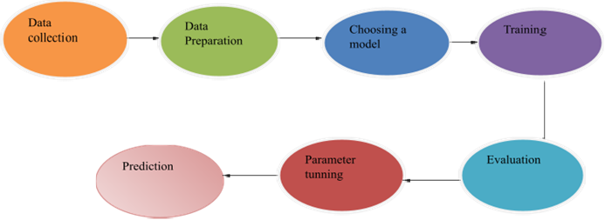

# Project Goal:

* + - The project helps to detect Heart failure risk diseases.
    - Medical and Testing lab help to easily find report of Heart Attack patient.
    - In Medical it helps for faster report generating.
    - User can easily fill the various symptom and finding the result very effectively.
    - It helps to manage time consuming less.

## Hardware requirement: -

Processor  : Any Update Processor

Ram : Min 4GB

Hard Disk : Min 100 GB

Monitor  : Display Panel (1024 X 764)

CPU : 1.7 GHZ

**Software Requirements:**

1. Operating System Windows Operating system are used.
2. Technology used For Implementation our project we used various programming language.

* For Backend-(Python 3.13)
* For Frontend- (HTML (Hypertext markup language), CSS (Cascading Style Sheet), Mater Lize CSS, JavaScript, Bootstrap)

3) IDE (Integrated development environment): VS-Code, Jupyter Notebook

4) Web browser: Google chrome, Internet Explorer, Mozilla Firefox.

5) Server: Flask Server: Used For deployment model running

**Chapter- 2 System Analysis and Design**

**Project scope: -**Machine Learning has the great ability to revolutionize the heart failure risk predictions with the help of advanced computational methods and availability of large amount of genetic heart failure risk dataset. Detection of heart attack in its early stages is the key for treatment.

Our study attempts to structure a framework which forecasts the risk pertaining to heart mellitus This work has described a machine learning approach to predicting heart levels.

The experimental result shows that the accuracy of Logistic Regression of our dataset is 81% which is the highest among the rest. The technique may also help researchers to develop an accurate and effective tool that will reach at the table of clinicians to help them make better decision about the disease status.

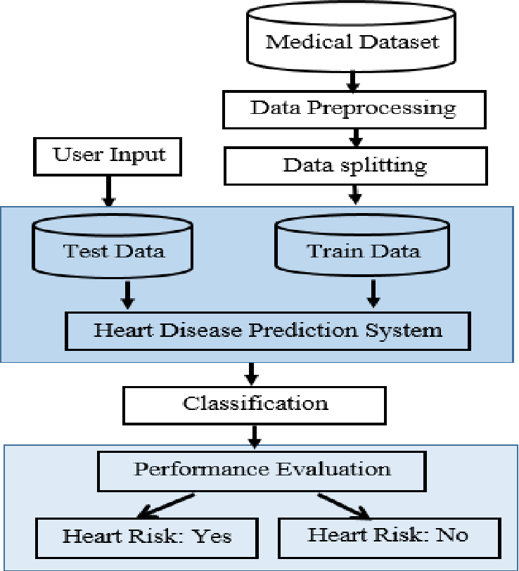 **Model Pipeline**

**System Architecture:**

The machine will predict whether the person has heart or not using the dataset. If heart is detected positive the classification value will be 1 and if negative the value will be 0. We will be using 2 machine learning model to the detect disease. The models used are logistic regression. The system architecture will help in the future too diagnosis heart. It will also predict whether someone has heart failure risk or not based on using a trained dataset.

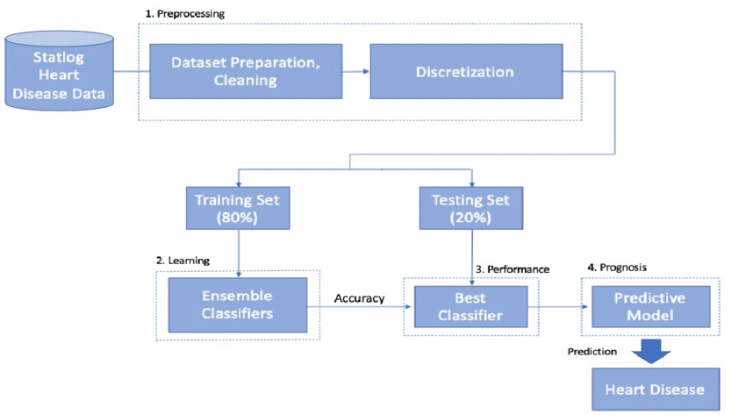  
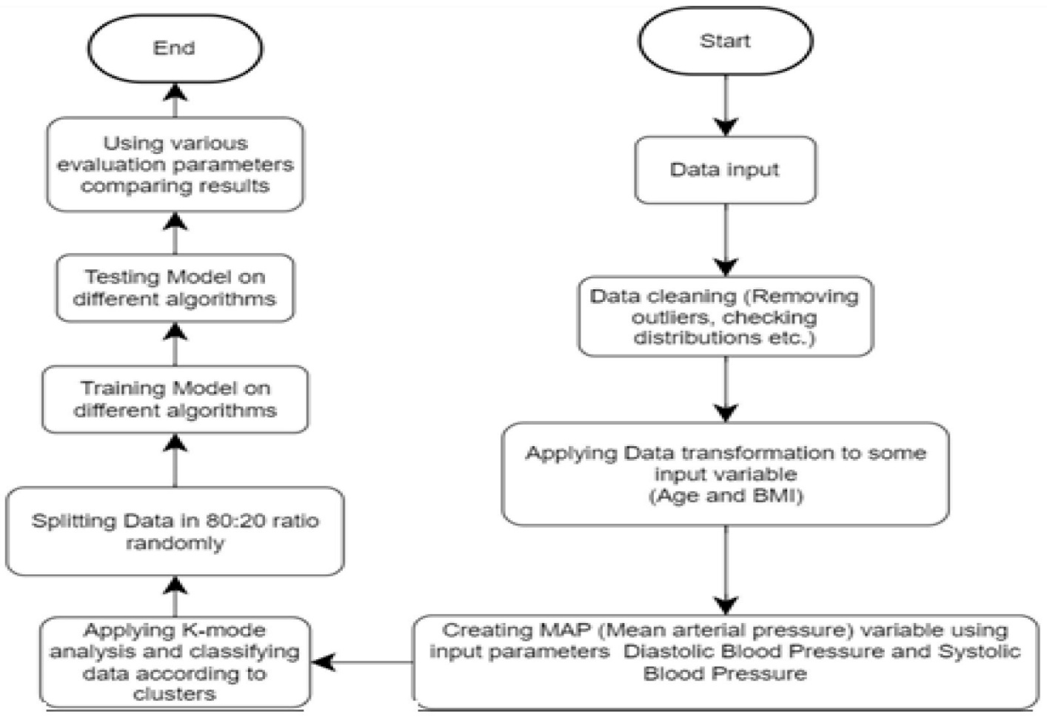

* 1. **Flowchart:**

**Proposed Algorithm:**

Step 1: Import Libraries required. Step2: Import dataset of heart.

Step3: Calculate accuracy of model: -It is ratio of number of predictions which are correct to the number of total predictions.

Accuracy = Number of Predictions which are correct /Number of total predictions.

Step 4: Automating workflow of machine learning for the algorithm providing best accuracy.

Step 5: Using random sampling divide the data in two parts: Train data and test data.

Step6: Train the model using data in trained dataset. Fit the model on logistic regression and predict the class of model on test data because it gives the best accuracy.

Step7: Predict whether the individual is heart failure risk or not. We have a model that can predict whether a people is heart patient or non-heart patient and their correlation coefficient through Logistic Regression.

It computes the probability of an event occurrence.

**Logistic Regression:** The one of the most common types of machine learning algorithm is logistic regression. The accuracy is usually high, and it is very reliable. It is also known as logistic model. The logistic regression gives results in 0s and 1s. Logistic Regression is very much like linear regression but there is one difference as well, in logistic regression curve is obtained and in linear regression straight line is obtained.

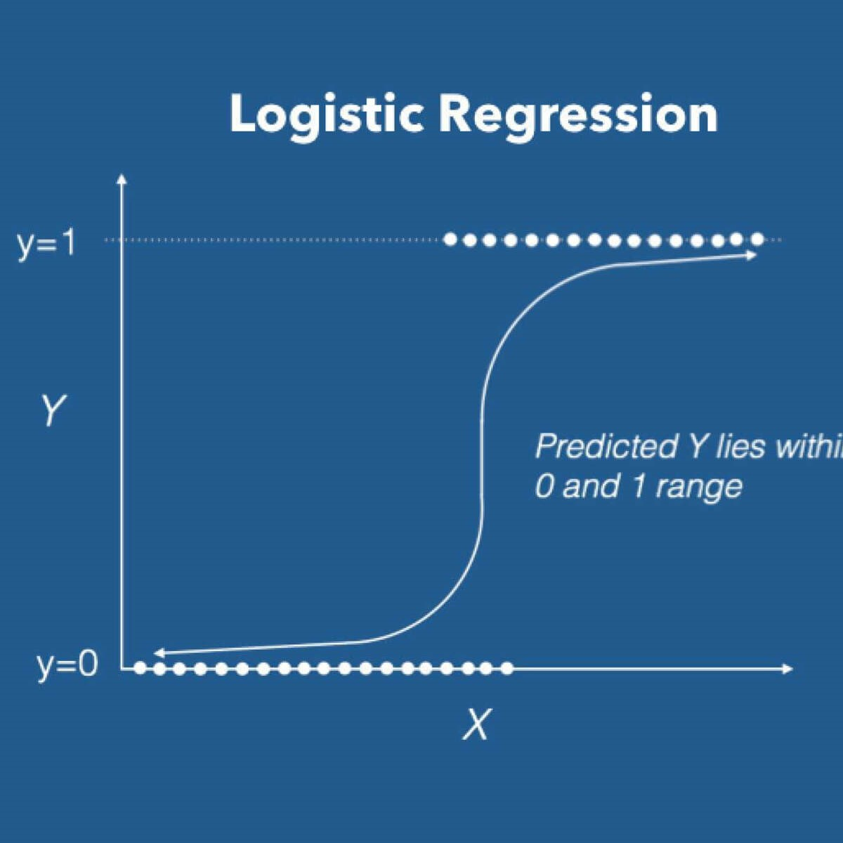

**Timeline of Project: -**

1st December-7th December,2024: - Literature Survey

8th December,2024 -15th January,2025: -Research Gap and founded the idea which can be proposed

16th January,2025 - 30th January,2025: - Prototype and Implementation of Machine Learning model, Accuracy Detection, Improving Dataset for better accuracy.

1st February,2025 - Present: - Working for more improvement, Integration with Flask, hosting our application on web.

**Chapter 3 Implementation and result**

**Implementation:**

* + 1. Importing some python libraries which used in model and read dataset using panda's library
    2. Extract some information about dataset

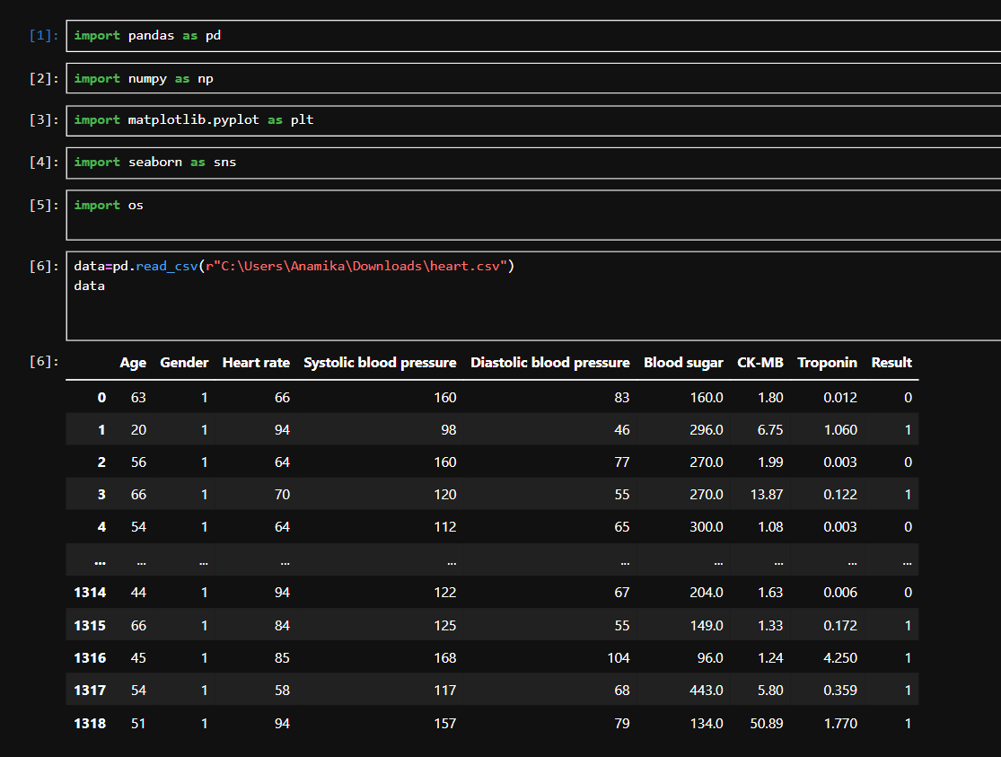

* + 1. Identify the data are null or not.

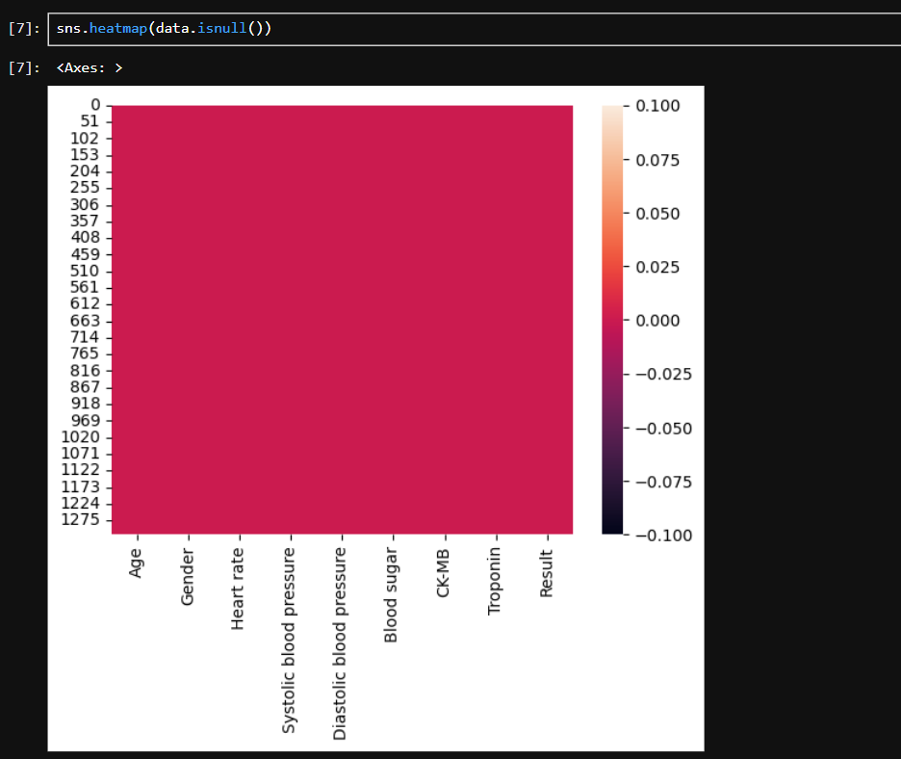

* + 1. Plotting histogram of patient class which specify positive and negative rate. From the graph we can conclude that the rate of positive (heart attack) is higher than negative (non-heart attack).

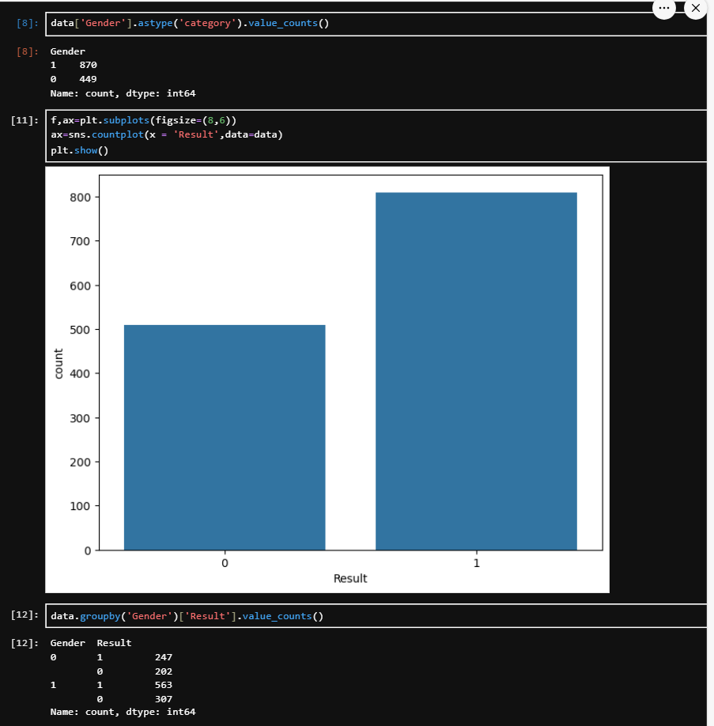

* + 1. Plot negative and positive class according to Age of heart patient and plotting distribution plot. The Distribution plot shown in fig 5. is based on the age attribute taken and the graph of age attribute is indicating that 40 to 85 aged person is more with heart diseases.

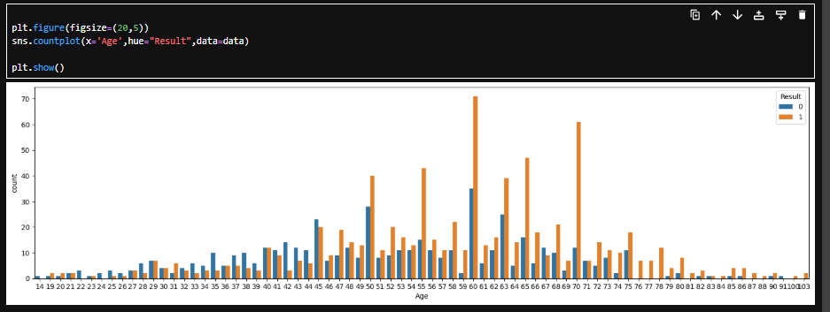

6. Calculate the Box Plot Numerical Data Features.

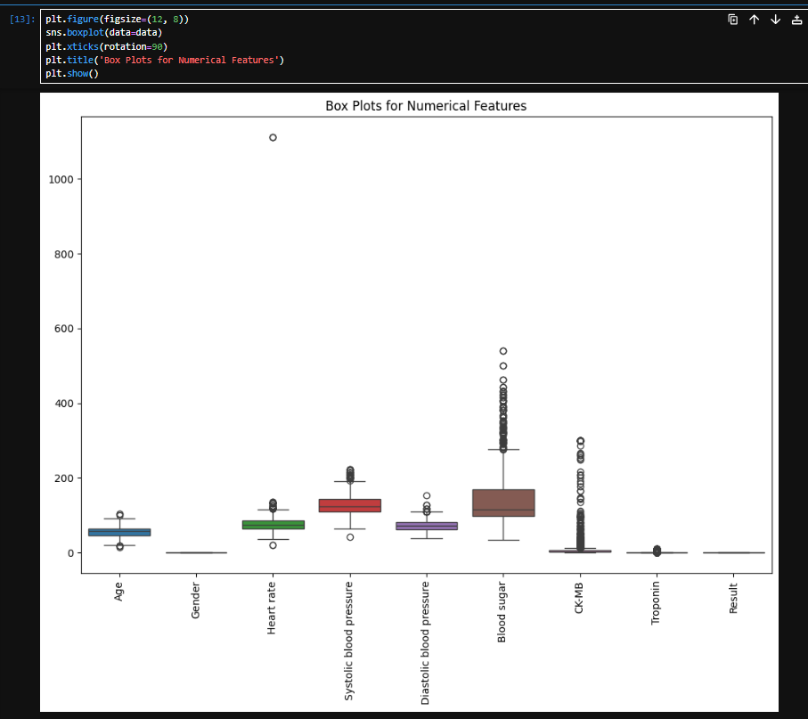

#### 7. Read crosstab according to age.

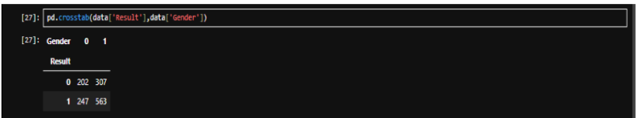

8. Find a Correlation datasets.

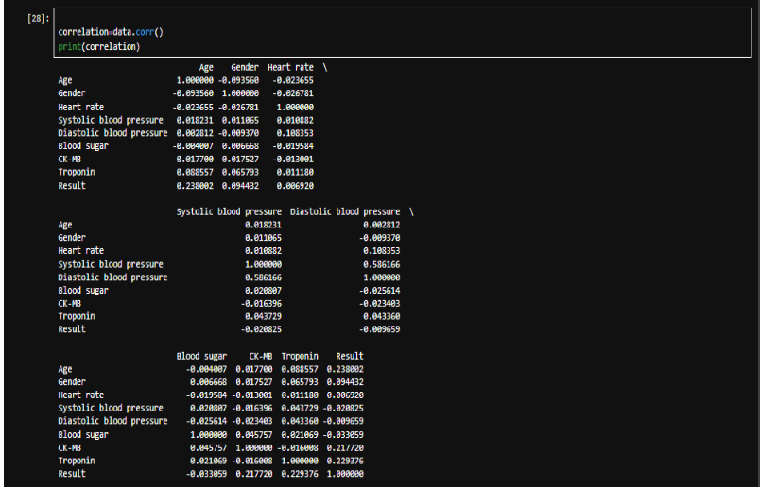

9. The histogram model below is shown. is based on the attributes Age, Gender, Systolic blood pressure, Diastolic blood pressure, Blood sugar, CK-MB, Troponin. The respective graph of each attribute is indicating that how much these respective attributes have effect on the heart attack for example, in age graph the people between the age group of 50 and 70 are mostly heart failure risk persons so this is how different age groups persons are affected by the heart. In the Gender graphs the effect of symptoms are represented here by 1(male) and 0(female). In the graph heart rate in the people between 80-150 are mostly heart failure risk prediction system. In the graph systolic blood pressure in the people between 120-50 are mostly heart failure risk prediction system. In the graph diastolic blood pressure in the people between 80-150 are mostly heart failure risk prediction system. In the graph systolic blood pressure in the people between 120-150 are mostly heart failure risk prediction system. Count the number of heart patient in dataset according to Gender.

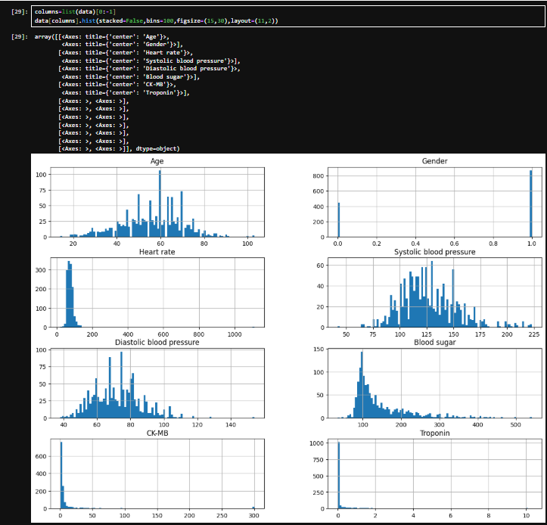

10. Correlation dataset attribute and find which attribute are more correlated.

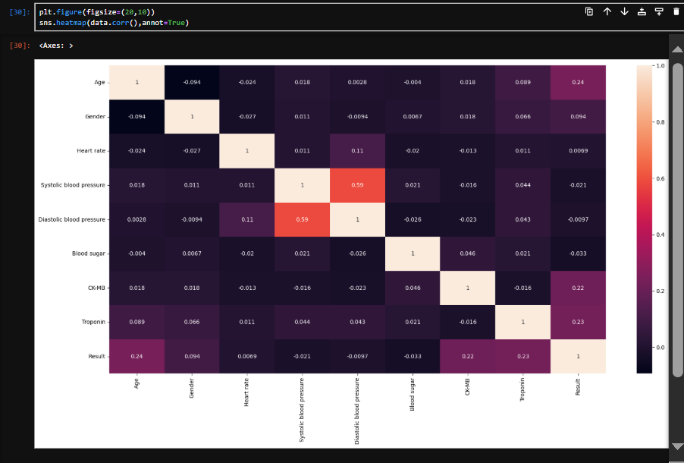

11. Importing sklearn model train and test.

Find the accuracy of model

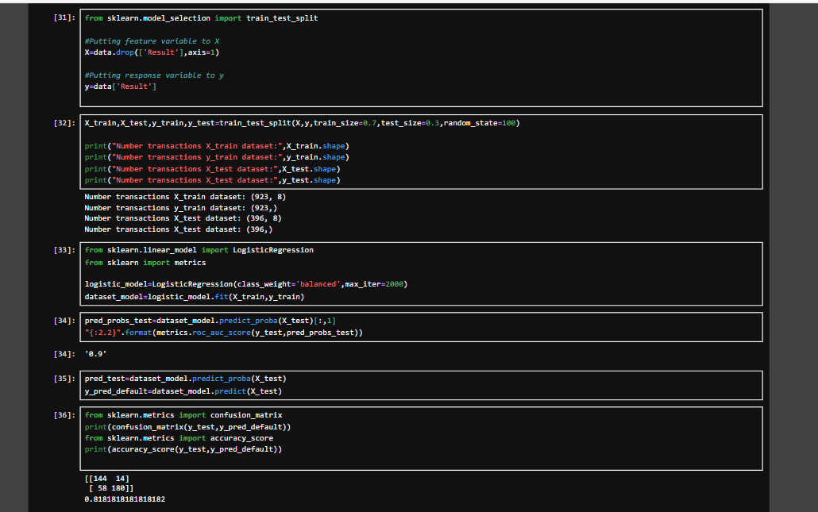

12. Generating a Confusion Matrix of given dataset.

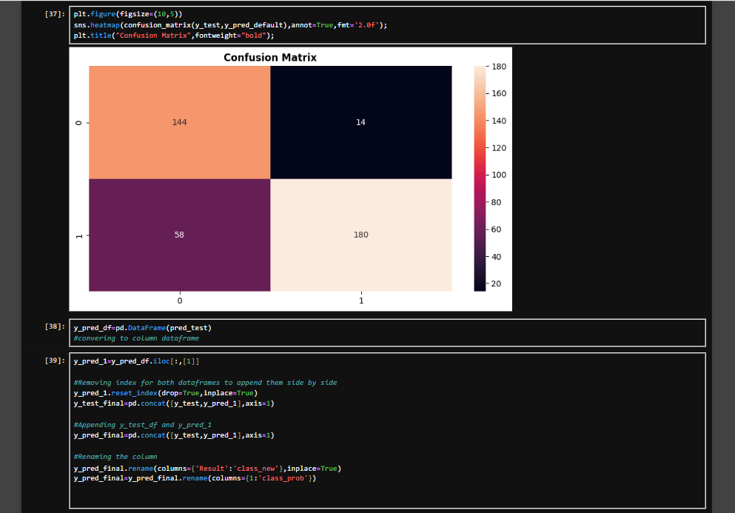  
13. Finally Predict Model.

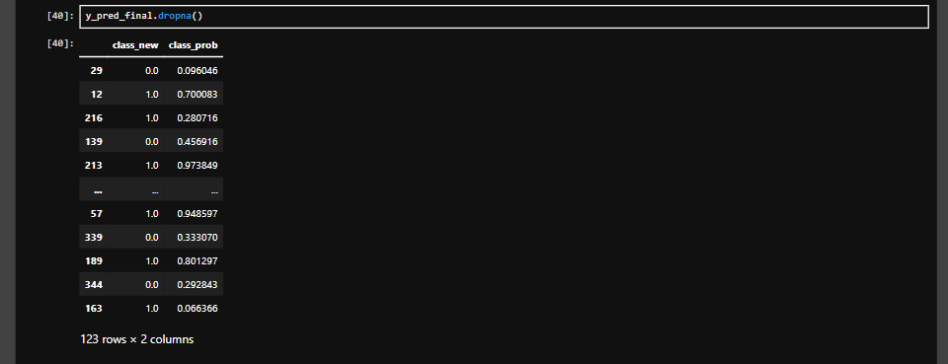

**Deploy model using flask:**

1). Converting model in webpage for better understanding and finding faster result.

This is the home screen. We click the start prediction button.

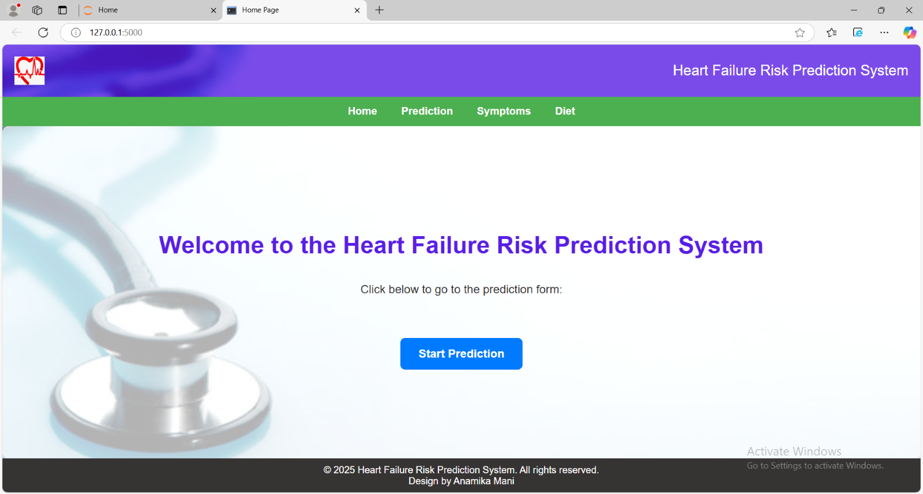

2). Fill the symptom form and click the predict button.

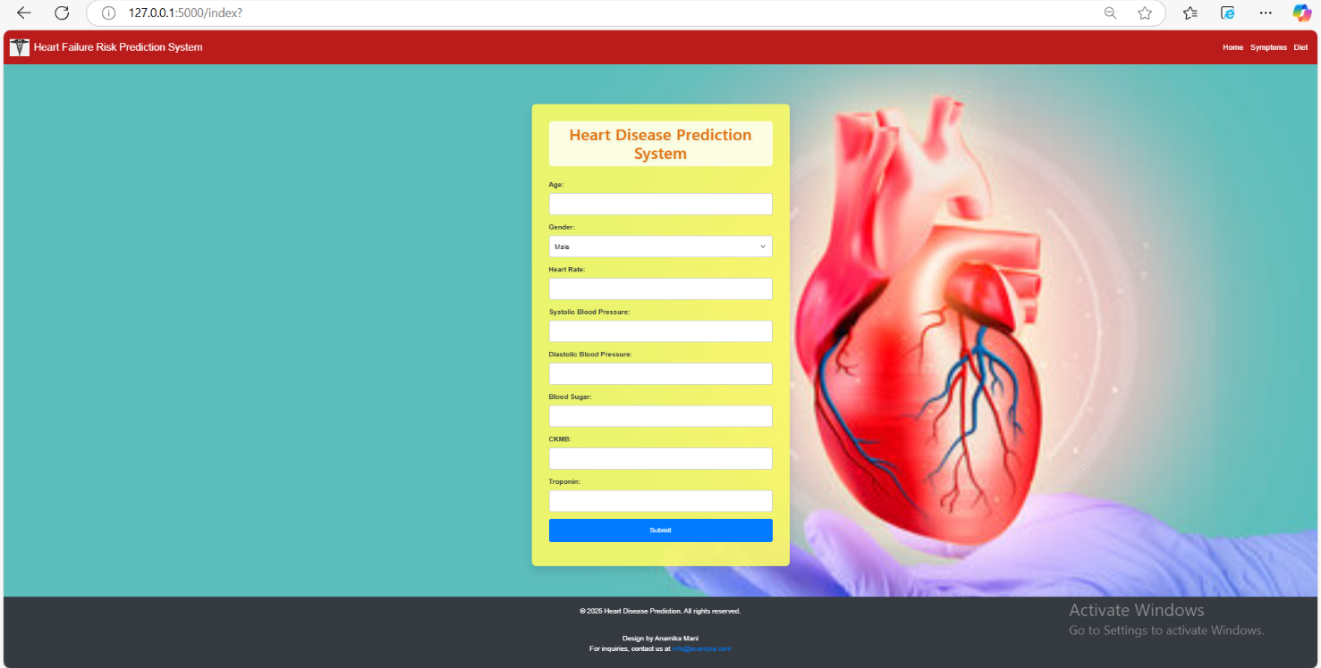

3). Positive report: Find the report of patient it shows the patient result and percentage for heart failure risk diseases.

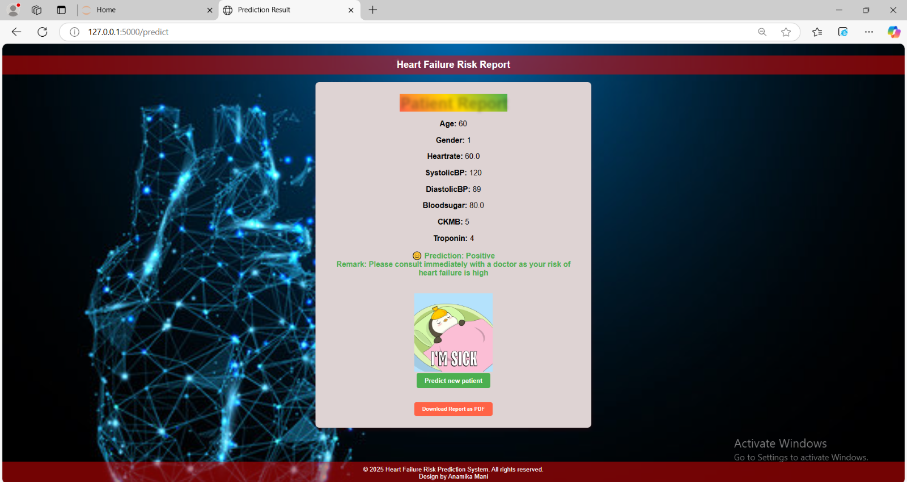

4). Negative report: Find the report of patient it shows the patient result and percentage for heart failure risk diseases.

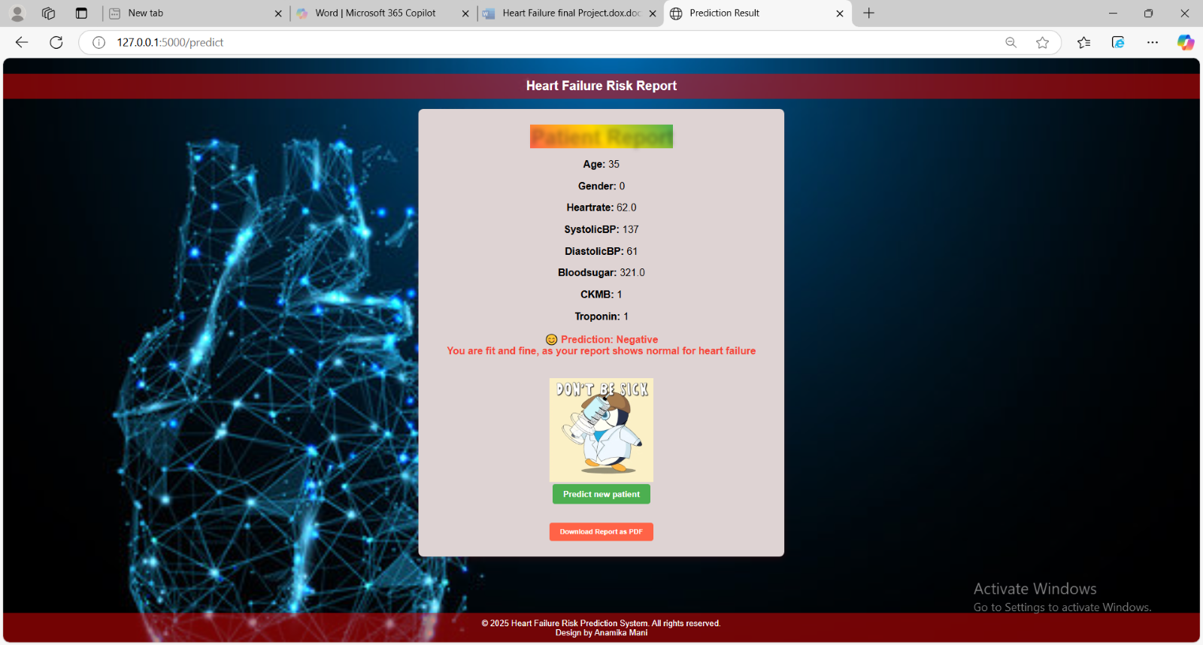

**Implementation Code:**

**1)Home.html**

<!DOCTYPE html>

<html lang="en">

<head>

<meta charset="UTF-8">

<meta name="viewport" content="width=device-width, initial-scale=1.0">

<title>Home Page</title>

<style>

/* Basic styling for the body */

body {

font-family: Arial, sans-serif;

background-color: #f4f4f4;

background-image: url('static/dil2.jpg'); /* Add your background image here */

background-size: cover; /* Makes sure the background image covers the entire body */

background-position: center; /* Center the background image */

background-attachment: fixed; /* Fixes the background when scrolling */

margin: 0;

padding: 0;

display: flex;

flex-direction: column;

min-height: 100vh;

justify-content: space-between; /* Ensures header and footer stay at the top and bottom */

}

/* Header Styling */

header {

background-color: rgba(89, 30, 228, 0.8); /* Semi-transparent background to contrast with the image */

color: white;

padding: 20px;

text-align: center;

font-size: 1.5em;

display: flex;

justify-content: space-between;

align-items: center;

}

/* Logo Styling */

.logo {

width: 50px; /* Adjust the size of the logo */

height: auto;

}

/* Navigation Bar Styling */

nav {

display: flex;

justify-content: center;

background-color: #4CAF50;

}

nav a {

padding: 14px 20px;

text-decoration: none;

color: white;

text-align: center;

font-size: 1.1em;

font-weight: bold;

}

nav a:hover {

background-color: #ddd;

color: black;

}

/* Footer Styling */

footer {

background-color: #363333;

color: white;

padding: 10px;

text-align: center;

font-size: 1em;

}

/* Main Content Styling */

.main-content {

display: flex;

flex-direction: column;

justify-content: center;

align-items: center;

flex-grow: 1; /* This ensures the main content takes the remaining space */

text-align: center; /* Centers the text horizontally */

padding: 20px;

background-color: rgba(255, 255, 255, 0.7); /* Semi-transparent background for the content */

border-radius: 10px;

}

/* Heading Styling */

h1 {

color: #591ee4;

font-size: 2.5em;

margin-bottom: 20px;

}

/* Description paragraph */

p {

color: #363333;

font-size: 1.2em;

margin-bottom: 30px;

}

/* Button Styling */

.btn {

padding: 15px 30px;

background-color: #007bff;

color: white;

font-size: 1.2em;

font-weight: bold;

border: none;

border-radius: 8px;

cursor: pointer;

transition: background-color 0.3s, transform 0.2s;

}

/* Hover effect */

.btn:hover {

background-color: #0056b3;

transform: scale(1.05);

}

/* Button focus effect */

.btn:focus {

outline: none;

}

/* Adding some space above the button */

.button-container {

margin-top: 40px;

}

</style>

</head>

<body>

<!-- Header with Logo -->

<header>

<img src="static/logo1.png" alt="Logo" class="logo"> <!-- Add your logo image here -->

<div>Heart Failure Risk Prediction System</div>

</header>

<!-- Navigation Bar -->

<nav>

<a href="{{ url_for('home') }}">Home</a>

<a href="{{ url_for('index') }}">Prediction</a>

<a href="{{ url_for('symptoms') }}">Symptoms</a>

<a href="{{ url_for('diet') }}">Diet</a>

</nav>

<!-- Main Content -->

<div class="main-content">

<h1>Welcome to the Heart Failure Risk Prediction System</h1>

<p>Click below to go to the prediction form:</p>

<div class="button-container">

<form action="{{ url_for('index') }}">

<button class="btn" type="submit">Start Prediction</button>

</form>

</div>

</div>

<!-- Footer -->

<footer>

&copy; 2025 Heart Failure Risk Prediction System. All rights reserved.<br>Design by Anamika Mani

</footer>

</body>

</html>

## 2)Symptoms.html

<!DOCTYPE html>

<html lang="en">

<head>

<meta charset="UTF-8">

<meta name="viewport" content="width=device-width, initial-scale=1.0">

<title>Heart Disease Risk and Symptoms</title>

<style>

body {

font-family: Arial, sans-serif;

background-color: #f2f2f2;

margin: 0;

padding: 0;

color: #333;

background-image: url('static/dit.jpg'); /* Background image URL */

background-size: cover; /* Scale the background image to cover the page */

background-attachment: fixed; /* Keep the background image fixed when scrolling */

}

header {

background-color: #c0392b;

color: white;

padding: 20px;

text-align: center;

border-bottom: 5px solid #e74c3c; /* Added a bottom border for emphasis */

}

nav {

background-color: #bdc3c7; /* Navigation bar background color */

padding: 10px;

text-align: center;

}

nav a {

margin: 0 15px; /* Margin between links */

color: #2c3e50; /* Link color */

text-decoration: none; /* Remove underline from links */

font-weight: bold; /* Make links bold */

}

nav a:hover {

color: #c0392b; /* Change color on hover */

}

.header-content {

max-width: 800px;

margin: auto;

}

h1 {

margin: 0;

font-size: 2.5em;

}

h2 {

margin: 5px 0;

font-size: 1.5em; /* Font size for subtitle */

font-weight: normal; /* Normal weight for subtitle */

}

.container {

max-width: 800px;

margin: 20px auto;

padding: 20px;

background-color: rgba(255, 255, 255, 0.8); /* White background with opacity */

border-radius: 8px;

box-shadow: 0 2px 10px rgba(0, 0, 0, 0.1);

}

h2, h3 {

color: #c0392b;

}

ul {

list-style-type: none;

padding: 0;

}

li {

background: #1cc7f1;

margin: 15px 0;

padding: 15px;

border-radius: 4px;

display: flex;

align-items: center;

}

li img {

width: 400px; /* Increased image width */

height: 400px; /* Increased image height */

margin-right: 20px; /* More space between image and text */

}

footer {

text-align: center;

margin-top: 20px;

padding: 10px;

font-size: 0.9em;

background-color: #56595b;

color: #2c3e50;

}

</style>

</head>

<body>

<header>

<h1>Heart Disease Risk and Symptoms</h1>

<h3>Understanding the Risks and Recognizing Symptoms</h3> <!-- Added subtitle -->

</header>

<nav>

<a href="{{ url_for('home') }}">Home</a> <!-- Link to home page -->

<a href="{{ url_for('index') }}">Prediction</a> <!-- Example link to an About page -->

<a href="{{ url_for('diet') }}">Diet</a> <!-- Example link to a Contact page -->

</nav>

<div class="container">

<h2>Understanding Heart Disease</h2>

<p>Heart disease includes various heart conditions, including coronary artery disease, congenital heart defects, and arrhythmias. It can affect anyone, and recognizing the risks and symptoms is crucial for early detection and management.</p>

<h2>Risk Factors</h2>

<ul>

<li>High cholesterol</li>

<li>High blood pressure</li>

<li>Smoking</li>

<li>Diabetes</li>

<li>Obesity</li>

<li>Lack of physical activity</li>

<li>Unhealthy diet</li>

<li>Family history of heart disease</li>

<li>Age (increased risk for those 45 and older for men, 55 and older for women)</li>

<li>Stress</li>

</ul>

<h2>Common Symptoms</h2>

<ul>

<li><img src="static/sym2.jpg" alt="Chest Pain">Heart failure symptoms</li>

<li><img src="static/sym3.png" alt="Shortness of Breath">Warning sign of heart fail risk</li>

<li><img src="static/sym4.webp" alt="Fatigue">sign of congestive heart failure</li>

<li><img src="static/sym5.jpg" alt="Heart Palpitations">congestive heart failure</li>

<li><img src="static/sym6.jfif" alt="Swelling in Legs">change heart size of heart risk</li>

<li><img src="static/sym7.jfif" alt="Dizziness">skin affect sign in heart fail</li>

</ul>

<h2>When to Seek Help</h2>

<p>If you experience chest pain or any symptoms that concern you, seek medical attention immediately. Early detection can save lives!</p>

</div>

<footer>

<p>Copyright 2025 Heart Health Awareness. All rights reserved.</p><br>Design by Anamika mani

</footer>

</body>

</html>

###### **3)Diet.html**

<!DOCTYPE html>

<html lang="en">

<head>

<meta charset="UTF-8">

<meta name="viewport" content="width=device-width, initial-scale=1.0">

<title>Diet for Heart Disease Risk Reduction</title>

<style>

body {

font-family: Arial, sans-serif;

background-color: #f2f2f2;

margin: 0;

padding: 0;

color: #333;

background-image: url('static/dit.jpg'); /* Background image URL */

background-size: cover; /* Scale the background image to cover the page */

background-attachment: fixed; /* Keep the background image fixed when scrolling */

}

header {

background-color: #c0392b;

color: white;

padding: 20px;

text-align: center;

border-bottom: 5px solid #e74c3c; /* Added a bottom border for emphasis */

}

header img {

width: 80px; /* Adjust the logo size */

height: auto;

margin-bottom: 10px; /* Space below the logo */

}

nav {

background-color: #bdc3c7; /* Navigation bar background color */

padding: 10px;

text-align: center;

}

nav a {

margin: 0 15px; /* Margin between links */

color: #2c3e50; /* Link color */

text-decoration: none; /* Remove underline from links */

font-weight: bold; /* Make links bold */

}

nav a:hover {

color: #c0392b; /* Change color on hover */

}

.header-content {

max-width: 800px;

margin: auto;

}

h1 {

margin: 0;

font-size: 2.5em;

}

h2 {

margin: 5px 0;

font-size: 1.5em; /* Font size for subtitle */

font-weight: normal; /* Normal weight for subtitle */

}

.container {

max-width: 800px;

margin: 20px auto;

padding: 20px;

background-color: rgba(255, 255, 255, 0.8); /* White background with opacity */

border-radius: 8px;

box-shadow: 0 2px 10px rgba(0, 0, 0, 0.1);

}

.container img {

width: 100%; /* Make the image responsive */

border-radius: 8px; /* Optional: adds rounded corners */

margin-bottom: 20px;

}

h2, h3 {

color: #c0392b;

}

ul {

list-style-type: none;

padding: 0;

}

li {

background: #27db81;

margin: 5px 0;

padding: 10px;

border-radius: 4px;

}

footer {

text-align: center;

margin-top: 20px;

padding: 10px;

font-size: 0.9em;

background-color: #bdc3c7;

color: #2c3e50;

}

</style>

</head>

<body>

<header>

<div class="header-content">

<img src="static/health.webp" alt="Heart Health Logo"> <!-- Add your logo here -->

<h1>Diet for Heart Disease Risk Reduction</h1>

<h2>Your Guide to Healthy Eating</h2> <!-- Added subtitle for clarity -->

</div>

</header>

<nav>

<a href="{{ url_for('home') }}">Home</a> <!-- Link to home page -->

<a href="{{ url_for('index') }}">Prediction</a> <!-- Example link to an About page -->

<a href="{{ url_for('symptoms') }}">Symptoms</a> <!-- Example link to a Contact page -->

</nav>

<div class="container">

<h2>Understanding the Importance of Diet</h2>

<p>Maintaining a healthy diet is crucial in reducing the risk of heart disease. A heart-healthy diet consists of foods that promote heart health and help in managing risk factors such as high cholesterol and high blood pressure.</p>

<h2>Key Dietary Recommendations</h2>

<ul>

<li><strong>Fruits and Vegetables:</strong> Aim for at least 5 servings a day of a variety of fruits and vegetables rich in vitamins, minerals, and fiber.</li>

<li><strong>Whole Grains:</strong> Choose whole grain options such as brown rice, whole wheat bread, and oatmeal which are high in fiber.</li>

<li><strong>Healthy Fats:</strong> Incorporate sources of healthy fats such as avocados, nuts, seeds, and olive oil while avoiding trans fats and saturated fats.</li>

<li><strong>Lean Proteins:</strong> Opt for lean protein sources like fish, skinless poultry, beans, and legumes instead of red and processed meats.</li>

<li><strong>Dairy:</strong> Choose low-fat or fat-free dairy options to reduce saturated fat intake.</li>

<li><strong>Limit Sugar and Salt:</strong> Reduce intake of added sugars and sodium. Read food labels to monitor your consumption.</li>

</ul>

<h2>Foods to Avoid</h2>

<ul>

<li>Processed meats (like bacon, sausages)</li>

<li>High-sugar snacks and desserts (like cookies and candies)</li>

<li>Fried foods</li>

<li>Refined carbohydrates (like white bread and pastries)</li>

<li>High-sodium packaged foods</li>

</ul>

<h2>Additional Tips</h2>

<p>In addition to dietary changes, maintain a healthy lifestyle through regular physical activity, maintaining a healthy weight, avoiding tobacco, and managing stress.</p>

<!-- Add a relevant heart disease image -->

<img src="static/diet1.webp" alt="Heart Health Image"><br>

<img src="static/diet2.png" alt="Heart Health Image"><br>

<img src="static/diet3.jpg" alt="Heart Health Image"><br>

<img src="static/diet4.jpg" alt="Heart Health Image"><br>

<img src="static/diet5.jpg" alt="Heart Health Image"><br>

<img src="static/diet6.jpeg" alt="Heart Health Image"><br>

</div>

<footer>

<p>© 2025 Heart Health Awareness. All rights reserved.</p><br>Design by Anamika mani

</footer>

</body>

</html>

###### **4) Index.html**

<!DOCTYPE html>

<html lang="en">

<head>

<meta charset="UTF-8">

<meta name="viewport" content="width=device-width, initial-scale=1.0">

<title>Heart Disease Prediction</title>

<!-- Bootstrap CSS CDN -->

<link *href="https://cdn.jsdelivr.net/npm/bootstrap@5.3.0-alpha1/dist/css/bootstrap.min.css*" rel="stylesheet">

<style>

/* Body Styles */

body {

background-image: url('static/dil1.jpg'); /* Your medical background image */

background-size: cover;

background-position: center;

background-attachment: fixed;

background-color: #f8f9fa;

font-family: Arial, sans-serif;

min-height: 100vh;

display: flex;

flex-direction: column;

justify-content: space-between;

}

/* Header and Navigation Bar */

.navbar {

background-color: #ba1b1b;

padding: 15px;

}

.navbar-brand {

color: white;

font-size: 24px;

display: flex;

align-items: center; /* Align logo and text */

}

.navbar-brand img {

height: 40px; /* Adjust the logo size */

margin-right: 10px; /* Space between the logo and text */

}

.navbar-nav .nav-link {

color: white;

font-size: 18px;

padding: 10px;

}

.navbar-nav .nav-link:hover {

color: #f8f9fa;

}

/* Container for the Form */

.container {

max-width: 600px;

background: rgba(249, 249, 101, 0.9); /* White background with slight opacity */

padding: 40px;

border-radius: 10px;

box-shadow: 0 10px 20px rgba(0, 0, 0, 0.1);

backdrop-filter: blur(5px); /* Optional: Adds blur effect behind the container */

margin-top: 60px; /* Adds space below the header */

}

h2 {

text-align: center;

color: #e4700b; /* Golden color */

font-family: 'Segoe UI', Tahoma, Geneva, Verdana, sans-serif; /* Modern font */

font-size: 36px; /* Increase the font size */

font-weight: 600; /* Slightly bold */

margin-bottom: 30px; /* Space between title and form */

text-shadow: 2px 2px 5px rgba(0, 0, 0, 0.1); /* Subtle shadow to make the text pop */

letter-spacing: 1px; /* Slight letter spacing for better readability */

padding: 10px 0; /* Vertical padding */

background: rgba(255, 255, 255, 0.8); /* Light background */

border-radius: 8px; /* Rounded corners for the background */

display: inline-block; /* Make it inline-block so it can have padding and background */

}

.form-label {

font-weight: bold;

color: #343a40;

}

.form-control {

border-radius: 5px;

padding: 12px;

border: 1px solid #ced4da;

}

.form-select {

border-radius: 5px;

padding: 12px;

border: 1px solid #ced4da;

}

.btn-primary {

width: 100%;

padding: 15px;

font-size: 16px;

border-radius: 5px;

background-color: #007bff;

border: none;

}

.btn-primary:hover {

background-color: #0056b3;

}

.error-message {

color: red;

text-align: center;

font-weight: bold;

margin-top: 20px;

}

/* Add some spacing between fields */

.mb-3 {

margin-bottom: 20px;

}

/* Footer Style */

.footer {

background-color: #343a40;

color: white;

padding: 20px;

text-align: center;

margin-top: 40px;

}

.footer a {

color: #007bff;

text-decoration: none;

}

.footer a:hover {

text-decoration: underline;

}

</style>

</head>

<body>

<!-- Header with Navigation Bar -->

<nav class="navbar navbar-expand-lg">

<a class="navbar-brand" href="{{ url_for('home') }}">

<img src="static/download.png" alt="Medical Logo"> <!-- Add your logo image here -->

Heart Failure Risk Prediction System

</a>

<div class="collapse navbar-collapse">

<ul class="navbar-nav ms-auto">

<li class="nav-item">

<a class="nav-link" href="{{ url_for('home') }}">Home</a>

</li>

<li class="nav-item">

<a class="nav-link" href="{{ url_for('symptoms') }}">Symptoms</a>

</li>

<li class="nav-item">

<a class="nav-link" href="{{ url_for('diet') }}">Diet</a>

</li>

</ul>

</div>

</nav>

<!-- Main Form Section -->

<div class="container">

<h2>Heart Disease Prediction System</h2>

<form method="POST" action="{{ url_for('predict') }}">

<div class="mb-3">

<label for="Age" class="form-label">Age:</label>

<input type="number" id="Age" name="Age" class="form-control" required>

</div>

<div class="mb-3">

<label for="Gender" class="form-label">Gender:</label>

<select id="Gender" name="Gender" class="form-select" required>

<option value="Male">Male</option>

<option value="Female">Female</option>

</select>

</div>

<div class="mb-3">

<label for="Heartrate" class="form-label">Heart Rate:</label>

<input type="number" id="Heartrate" name="Heartrate" class="form-control" required>

</div>

<div class="mb-3">

<label for="SystolicBP" class="form-label">Systolic Blood Pressure:</label>

<input type="number" id="SystolicBP" name="SystolicBP" class="form-control" required>

</div>

<div class="mb-3">

<label for="DiastolicBP" class="form-label">Diastolic Blood Pressure:</label>

<input type="number" id="DiastolicBP" name="DiastolicBP" class="form-control" required>

</div>

<div class="mb-3">

<label for="Bloodsugar" class="form-label">Blood Sugar:</label>

<input type="number" id="Bloodsugar" name="Bloodsugar" class="form-control" required>

</div>

<div class="mb-3">

<label for="CKMB" class="form-label">CKMB:</label>

<input type="number" id="CKMB" name="CKMB" class="form-control" required>

</div>

<div class="mb-3">

<label for="Troponin" class="form-label">Troponin:</label>

<input type="number" id="Troponin" name="Troponin" class="form-control" required>

</div>

<div class="mb-3">

<input type="submit" value="Submit" class="btn btn-primary">

</div>

</form>

{% if error %}

<p class="error-message">{{ error }}</p>

{% endif %}

</div>

<!-- Footer -->

<div class="footer">

<p>&copy; 2025 Heart Disease Prediction. All rights reserved.</p><br>Design by Anamika Mani

<p>For inquiries, contact us at <a *href="mailto:info@example.com">info@example.com</a></p*>

</div>

<!-- Bootstrap JS and Popper.js CDN -->

<script *src="https://cdn.jsdelivr.net/npm/@popperjs/core@2.11.6/dist/umd/popper.min.js"></script*>

<script *src="https://cdn.jsdelivr.net/npm/bootstrap@5.3.0-alpha1/dist/js/bootstrap.min.js"></script*>

</body>

</html>

###### **5) Show.html**

<!DOCTYPE html>

<html lang="en">

<head>

<meta charset="UTF-8">

<meta name="viewport" content="width=device-width, initial-scale=1.0">

<title>Prediction Result</title>

<script src="https://cdnjs.cloudflare.com/ajax/libs/jspdf/2.5.1/jspdf.umd.min.js"></script> <!-- Include jsPDF -->

<style>

/* Reset some basic styles for consistency */

* {

margin: 0;

padding: 0;

box-sizing: border-box;

}

body {

background-image: url('static/dil.jpg');

background-size: cover; /* Ensure background covers the whole screen */

font-family: 'Arial', sans-serif;

background-color: #f4f7fc;

display: flex;

flex-direction: column;

justify-content: flex-start;

min-height: 100vh; /* Ensure the body takes up the full height */

text-align: center;

padding-top: 30px; /* Add space at the top for the header */

}

header {

width: 100%;

padding: 10px;

background-color: rgba(238, 5, 5, 0.5); /* Semi-transparent black background */

color: white;

font-size: 1.5em;

font-weight: bold;

text-align: center;

margin-bottom: 20px;

}

footer {

width: 100%;

padding: 10px;

background-color: rgba(229, 6, 6, 0.5); /* Semi-transparent black background */

color: white;

font-size: 1em;

text-align: center;

position: relative;

bottom: 0;

margin-top: auto; /* Push footer to the bottom if content is less */

}

h1 {

font-size: 3em;

color: #eeee29;

font-weight: bold;

letter-spacing: 2px;

text-transform: uppercase;

margin-bottom: 20px; /* Add spacing below h1 */

}

.container {

background-color: #ded3d3;

border-radius: 10px;

box-shadow: 0 4px 12px rgba(242, 5, 5, 0.1);

width: 100%;

max-width: 700px;

padding: 30px;

text-align: center;

margin: 0 auto; /* Center the container horizontally */

display: flex;

flex-direction: column;

align-items: center;

justify-content: center;

}

h2 {

font-size: 2.5em;

background: linear-gradient(45deg, #FF6347, #FFD700, #4CAF50);

color: transparent;

font-weight: bold;

text-shadow: 2px 2px 8px rgba(0, 0, 0, 0.3);

margin-bottom: 20px;

}

p {

font-size: 1.2em;

margin-bottom: 20px;

}

.result-positive {

color: #4CAF50;

font-weight: bold;

}

.result-negative {

color: #F44336;

font-weight: bold;

}

a {

display: inline-block;

background-color: #4CAF50;

color: #fff;

text-decoration: none;

padding: 10px 20px;

border-radius: 5px;

font-weight: bold;

transition: background-color 0.3s;

}

a:hover {

background-color: #45a049;

}

/* Add responsiveness */

@media (max-width: 480px) {

h1 {

font-size: 2.2em;

margin-bottom: 15px;

}

h2 {

font-size: 2em;

}

p {

font-size: 1em;

}

.container {

padding: 20px;

}

}

/* GIF Styles */

.gif-container {

margin-top: 20px;

display: inline-block;

}

.gif-container img {

max-width: 200px; /* Limit GIF size */

max-height: 200px;

}

</style>

</head>

<body>

<header>

Heart Failure Risk Report

</header>

<div class="container" id="report-container">

<h2>Patient Report</h2>

<!-- Display form data -->

<div>

<p><strong>Age:</strong> {{ Age }}</p>

<p><strong>Gender:</strong> {{ Gender }}</p>

<p><strong>Heartrate:</strong> {{ Heartrate }}</p>

<p><strong>SystolicBP:</strong> {{ SystolicBP }}</p>

<p><strong>DiastolicBP:</strong> {{ DiastolicBP }}</p>

<p><strong>Bloodsugar:</strong> {{ Bloodsugar }}</p>

<p><strong>CKMB:</strong> {{ CKMB }}</p>

<p><strong>Troponin:</strong> {{ Troponin }}</p>

</div>

<!-- Prediction result with emoji and GIF -->

<p class="{% if prediction == 1 %}result-positive{% else %}result-negative{% endif %}">

<!-- Add emoji based on prediction result -->

{% if prediction == 1 %}

😞 Prediction: Positive<br>Remark: Please consult immediately with a doctor as your risk of heart failure is high

{% else %}

😊 Prediction: Negative<br>You are fit and fine, as your report shows normal for heart failure

{% endif %}

</p>

<!-- GIF container, will show based on prediction -->

<div class="gif-container">

{% if prediction == 1 %}

<img src="static/giphy.webp" alt="Positive Result">

{% else %}

<img src="static/gip.gif" alt="Negative Result">

{% endif %}

</div>

<a href="/">Predict new patient</a>

<br><br>

<!-- Download Button -->

<button id="download-pdf" style="background-color: #FF6347; color: white; padding: 10px 20px; border: none; border-radius: 5px; font-weight: bold;">Download Report as PDF</button>

</div>

<footer>

&copy; 2025 Heart Failure Risk Prediction System. All rights reserved.<br>Design by Anamika Mani

</footer>

<script>

// Function to generate PDF using jsPDF

document.getElementById('download-pdf').addEventListener ('click' , 'function()')

{

const { jsPDF } = window.jspdf;

const doc = new jsPDF();

// Add content to the PDF

doc.setFontSize(16);

doc.text('Heart Failure Risk Report', 20, 20);

doc.text('Patient Report', 20, 40);

doc.text('Age: {{ Age }}', 20, 50);

doc.text('Gender: {{ Gender }}', 20, 60);

doc.text('Heartrate: {{ Heartrate }}', 20, 70);

doc.text('SystolicBP: {{ SystolicBP }}', 20, 80);

doc.text('DiastolicBP: {{ DiastolicBP }}', 20, 90);

doc.text('Bloodsugar: {{ Bloodsugar }}', 20, 100);

doc.text('CKMB: {{ CKMB }}', 20, 110);

doc.text('Troponin: {{ Troponin }}', 20, 120);

// Add Prediction result

if (prediction == 1) {

doc.setTextColor(244, 67, 54); // Red color for negative prediction

doc.text('Prediction: Positive', 20, 130);

doc.text('Remark: Please consult immediately with a doctor as your risk of heart failure is high', 20, 140);

} else {

doc.setTextColor(76, 175, 80); // Green color for negative prediction

doc.text('Prediction: Negative', 20, 130);

doc.text('You are fit and fine, as your report shows normal for heart failure', 20, 140);

}

// Save the generated PDF

doc.save('Heart_Failure_Report.pdf');

}

</script>

</body>

</html>

## 6) App.py

from flask import Flask, render_template, request

import pickle

import pandas as pd

import numpy as np

# Load the Random Forest Classifier model

filename = 'pickle.pkl'

model = pickle.load(open(filename, 'rb'))

app = Flask(__name__)

@app.route('/')

def home():

return render_template('home.html')

@app.route('/symptoms')

def symptoms():

return render_template('symptoms.html')

@app.route('/diet')

def diet():

return render_template('diet.html')

@app.route('/index')

def index():

return render_template('index.html')

@app.route('/predict', methods=['GET', 'POST'])

def predict():

if request.method == 'POST':

try:

# Extracting the form data and validating

Age = request.form.get('Age')

Gender = request.form.get('Gender')

Heartrate = request.form.get('Heartrate')

SystolicBP = request.form.get('SystolicBP')

DiastolicBP = request.form.get('DiastolicBP')

Bloodsugar = request.form.get('Bloodsugar')

CKMB = request.form.get('CKMB')

Troponin = request.form.get('Troponin')

# Ensure all required values are provided

if not Age or not Gender or not Heartrate or not SystolicBP or not DiastolicBP or not Bloodsugar or not CKMB or not Troponin:

return render_template('index.html', error="Please fill in all fields.")

# Convert numerical values to appropriate types (handling None/empty values)

Age = int(Age) if Age else 0

Heartrate = float(Heartrate) if Heartrate else 0.0

SystolicBP = int(SystolicBP) if SystolicBP else 0

DiastolicBP = int(DiastolicBP) if DiastolicBP else 0

Bloodsugar = float(Bloodsugar) if Bloodsugar else 0.0

CKMB = int(CKMB) if CKMB else 0.0

Troponin = int(Troponin) if Troponin else 0.0

# Convert categorical data like 'Gender' into numerical representation if necessary

# Assuming Gender is either 'Male' or 'Female', you may need to map this

Gender = 1 if Gender == 'Male' else 0 # For example, map 'Male' to 1 and 'Female' to 0

# Prepare the data for prediction

data = np.array([[Age, Gender, Heartrate, SystolicBP, DiastolicBP, Bloodsugar, CKMB, Troponin]])

# Make the prediction

my_prediction = model.predict(data)

# Returning the prediction result

return render_template('show.html',Age=Age, Gender=Gender, Heartrate=Heartrate,

SystolicBP=SystolicBP, DiastolicBP=DiastolicBP, Bloodsugar=Bloodsugar,

CKMB=CKMB, Troponin=Troponin, prediction=my_prediction[0])

except Exception as e:

return render_template('index.html', error=f"An error occurred: {str(e)}")

if __name__ == '__main__':

app.run(debug=True)

**7) Predict.py**

import pandas as pd

import numpy as np

from sklearn.linear_model import LogisticRegression

from sklearn.model_selection import train_test_split

from sklearn.preprocessing import StandardScaler

import pickle

data=pd.read_csv(r"C:/Users/Anamika/Downloads/heart.csv")

df = pd.DataFrame(data)

X = df[['Age','Gender','Heartrate','SystolicBP','DiastolicBP','Bloodsugar','CKMB','Troponin']]

y = df['Result']

X_train, X_test, y_train, y_test = train_test_split(X, y, test_size=0.2, random_state=42)

scaler = StandardScaler()

X_train_scaled = scaler.fit_transform(X_train)

X_test_scaled = scaler.transform(X_test)

model = LogisticRegression()

model.fit(X_train_scaled, y_train)

with open('pickle.pkl', 'wb') as file:

pickle.dump(model, file)

## Result Analysis:

The results have been collected of used logistic algorithms. The accuracy is each of the algorithm used.

|  |  |
| --- | --- |
| **Logistic regression** | **81%** |

**Chapter 4 Conclusion and future enhancement**

**Conclusion:**

We have used different types of machine learning algorithm for detection of how heart attack has occurred. We implemented machine learning algorithms on the dataset and performed classification to signify the best machine learning algorithm for heart failure risk prediction on the bases of old data available. The higher accuracy the better prediction rate we will achieve. The logistic regression algorithm obtained the best accuracy. While on the other hand logistic regression had the lowest score. We get accuracy of 81% using this algorithm.

**Scope of future enhancement:**

The model improves accuracy and precision of heart attack prediction with this dataset compared to existing dataset. The overall experimentation displayed that logistic regression is better than other algorithms in heart attack prediction. In our future work we will work on the diagnosis of heart attack in young people.

**References:**

1. <https://www.kaggle.com/datasets/sukhmandeepsinghbrar/heart-attack-dataset>.
2. Ujma Ansari, Jyoti Soni, Dipesh Sharma, Sunita Soni. “Predictive Data Mining for Medical Diagnosis: An Overview of Heart Disease Prediction”, 258493784_Predictive_Data_Mining_fo r_Medical_Diagnosis_An_Overview_of_Heart_Disease_Prediction.
3. Jabbar Akhil, Shirina Samreen, “Heart disease prediction system based on hidden naïve Bayes classifier”, <https://www.researchgate.net/publication/309735105_Heart_disease_prediction_system_based_on_hidden_naive_Bayes_classifier>, October 2016.
4. <https://www.medicalnewstoday.com/articles/257484.php>
5. Nimai Chand Das Adhikari, Arpana Alka, and rajat Garg, “HPPS: Heart Problem Prediction System using Machine Learning”.
6. K. Polaraju, D. Durga Prasad, “Prediction of Heart Disease using Multiple Linear Regression Model”, International Journal of Engineering Development and Research Development, ISSN:2321-9939, 2017.
7. Marjia Sultana, Afrin Haider, “Heart Disease Prediction using WEKA tool and 10-Fold cross-validation”, The Institute of Electrical and Electronics Engineers, March 2017.
8. V. Manikantan & S.Latha,”Predicting the Analysis of Heart Disease Symptoms Using Medicinal Data Mining Methods”, International Journal on Advanced Computer Theory and Engineering, Volume-2, Issue-2, pp.5-10, 2013.
9. Dr.A.V.Senthil Kumar, “Heart Disease Prediction Using Data Mining preprocessing and Hierarchical Clustering”, International Journal of Advanced Trends in Computer Science and Engineering, Volume-4, No.6, pp.07-18, 2015.
10. Uma.K, M.Hanumathappa, “Heart Disease Prediction Using Classification Techniques with Feature Selection Method”, Adarsh Journal of Information Technology, Volume-5, Issue-2, pp.22-29, 2016.
11. Himanshu Sharma, M.A.Rizvi, “Prediction of Heart Disease using Machine Learning Algorithms:A Survey”,International Journal on Recent and Innovation Trends in Computing and Communication, Volume5,Issue-8, pp.99-104, 2017.